 | American International University-Bangladesh (AIUB)  Department of Computer Science
 | Course Name: COMPUTER GRAPHICS |  | Course Code: CSE 4118
 | Faculty Name: DIPTA JUSTIN GOMES |  | Semester: FALL 2025-2026
 | Section: J  Student Name: NILOY PAUL |  | FINAL Term LAB Task-1  Student ID: 23-51773-2

Transformation Lab – 2
Create the given object with co-ordinates (x,y) with a co-ordinate system of gluOrtho2D( 200, 200, -300, 300). The object has translated (tx=3, ty=4), rotated in 175 deg and scaled into (sx =3, sy=4). Draw both the original object before transformation and transformed object using OpenGL. The

Final output of the Object:

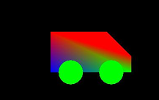

OpenGL Code
#include <windows.h>
#include <GL/glut.h>
#include <cmath>

float angle = 175.0f;
const float PI = 3.14159265f;

// Draw a circle for wheels
void drawWheel(float x, float y, float radius) {
glBegin(GL_POLYGON);
for (int i = 0; i < 360; i++) {
float theta = i * PI / 180.0f;
glVertex2f(x + radius * cos(theta), y + sin(theta) * radius);
}
glEnd();
}

void drawCarShape() {

// 1. Define the 5 points of the Pentagon (Van Shape)
float points[5][2] = {
{-25, 0}, // 0: Bottom-Back
{ 25, 0}, // 1: Bottom-Front
{ 25, 12}, // 2: Front-Hood
{ 10, 22}, // 3: Top-Windshield (The Pentagon "Point")
{-25, 22} // 4: Top-Back
};

float Angle = -175.0f * PI / 180.0f;

// Draw the Body with Gradient (Red top, Green bottom)
glBegin(GL_POLYGON);
for (int i = 0; i < 5; i++) {

float x = points[i][0] * cos(Angle) - points[i][1] * sin(Angle);
float y = points[i][0] * sin(Angle) + points[i][1] * cos(Angle);

if (i >= 3) glColor3f(1.0f, 0.0f, 0.0f); // Red Top
else glColor3f(0.0f, 1.0f, 0.0f); // Green Bottom
glVertex2f(x, y);
}
glEnd();

// Draw Wheels
glColor3f(0.0f, 1.0f, 0.0f);
float wheelPos[2][2] = {{-15, -3}, {15, -3}};
for (int i = 0; i < 2; i++) {
float wx = wheelPos[i][0] * cos(Angle) - wheelPos[i][1] * sin(Angle);
float wy = wheelPos[i][0] * sin(Angle) + wheelPos[i][1] * cos(Angle);
drawWheel(wx, wy, 6);
}
}

void display() {
glClear(GL_COLOR_BUFFER_BIT);
glLoadIdentity();

//1. DRAW PRIMARY CAR (Before Transformation)
glPushMatrix();
glTranslatef(-120.0f, 100.0f, 0.0f);
drawCarShape();
glPopMatrix();

// 2. DRAW TRANSFORMED CAR
glPushMatrix();
glTranslatef(3.0f, 4.0f, 0.0f); // tx=3, ty=4
glRotatef(angle, 0.0f, 0.0f, 1.0f); // Rotation = 175
glScalef(3.0f, 4.0f, 1.0f); // sx=3, sy=4

drawCarShape();
glPopMatrix();

glutSwapBuffers();
}

void init() {
glClearColor(0.0f, 0.0f, 0.0f, 1.0f);
glMatrixMode(GL_PROJECTION);
glLoadIdentity();
gluOrtho2D(-200, 200, -300, 300);
glMatrixMode(GL_MODELVIEW);
}

int main(int argc, char** argv) {
glutInit(&argc, argv);
glutInitDisplayMode(GLUT_DOUBLE | GLUT_RGB);
glutInitWindowSize(800, 600);
glutCreateWindow("Transformation Lab - Final Pentagon Car");

init();
glutDisplayFunc(display);
glutMainLoop();
return 0;
}
Output
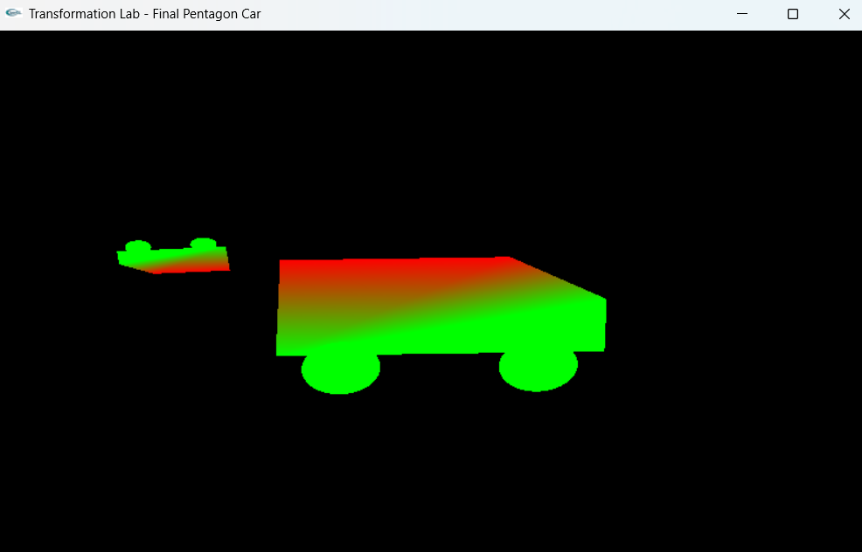

THE END

